U-7 Mini Indoor Laws
If teams aren't even players can be borrowed from one team to another, so they are even and everyone get's equal playing time. 5v5 with a keeper is the usual but can play 4v4 or 3v3 etc. if short players.

The Ball:
U-7 Size 3 (Roster size 12)

The Time:
20 minutes pre-game practice
2 to 3 Activities
2 equal halves of 15 minutes and 5-minute break
5 Minutes change over between the next game.
The Field:
Half of the indoor field U-7

Players Benches:
Both teams will share the same bench and dressing room.

Player Changes:
Player changes should be every 3 minutes (goalies can be changed at this time)

Number of Players on the Field:
U-7 Each team will have 4 players and 1 goalkeeper on the field at any one time. (In order to reduce the number of players on the field and to get closer to outdoor numbers)
Ball in and out of Play:

U-7
- At the Indoor Centre: If the ball goes out the side or hits the net then the ball will be placed where it exited the field. It will be placed on the ground and kicked into play by the team that did not put the ball out of play. All opposing players must be at least 5 yards away. 
- If the ball exits the touchlines (goal keepers ends) then it will be a goal kick. Regardless of who touched it last. 
- The goalie or defender must kick the ball outside the crease and the opposing players must be on their half until the kick is made. 

Scoring: Goals can be scored from anywhere on the field including the crease.

Goal Crease:
- The goalie is only allowed to use his/her hands inside the crease. If they wander out of the crease they are to be warned. 
- All goal kicks will be kicked from within the goal crease (at the top of the crease would be recommended).  Free Kicks:
For the mini program all kicks will be Indirect. Indirect kicks means that the ball must be passed or touched by another player before a goal can be scored.
Hand-ball:
All intentional handballs will result in the coach awarding an in-direct free kick to the non-offending team. Players must be 5 yards away. Except for infractions within the goal crease. The whistle will blow and the ball will be placed at the top of the crease for an In-Direct free kick. Players can make a “wall” on the goal line.

Aggressive behavior:
Including - pushing, kicking, punching, hitting will result in an In-Direct free kick to the non-offending team, as well as the player sitting for a minimum of 1 full shift (coach’s responsibility).

Rotation of Players:
Coaches are encouraged to rotate the players on their team so that every player has an opportunity at each position.
The Coaches:
- There will be one coach from each team on the field to help with the flow of the game. Each coach will take one side. 
- One coach or parent from each team will be on the bench to direct the players on to the field.
- On a single gender team there must be a coach the same gender as the
players (bench mom or dad).
- There are no referees at this age. Coaches are encouraged to share the job of being the “ref” for their team.
Fair Play:

U-7 Due to the creases in the indoor game not being of equal size (on some fields) as well as the boards being only on one side teams will switch sides at half, to give each team an opportunity to have the boards and a smaller crease.
Retreat Line:

U7 Indoor Center Retreat Line
Retreat Line The Retreat Line will come into effect in three situations during the game:
- A Goal Kick
- A Free Kick to the defending team within its own goal area
- The Goalie has the ball in their hands
At these three restarts, the opposing team is required to move beyond the Retreat Line. The player taking the kick can then pass the ball to one of his/her team-mates without the pressure of an opposing player nearby. When the ball has left the goal area, the play will resume as normal and the “opposing” team can move inside the Retreat Line.
The Retreat Line in Mini Soccer will be the Halfway Line.
If a member of the opposing team comes inside the Retreat Line before the ball has left the goal area and interferes with play, the Coach will stop play and the restart will be retaken.
During the Indoor Soccer Game U7 play on half of the indoor field. The Retreat line is at Half of the field. There are no Clear Markings at this time so please do your best to have your players at half or use disc cones.

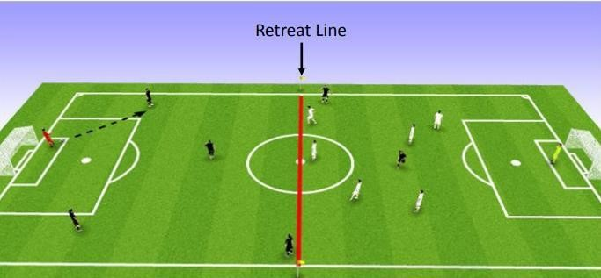
Mini Soccer – FAQ’s
What is Mini Soccer?
Mini Soccer is a game designed to improve our young players appreciation for the game of soccer. We want them to have fun!! By providing an environment in which they get “more touches on the ball” mini soccer allows these youngsters to do just that while at the same time giving them the opportunity to improve their ball skills within the game of soccer (touching the ball more often is always more fun – right?). Teams at this age play only 1 game per week. Usually no regular practices. There are no refs at this age. Coaches are encouraged to share the job of being the ref. Each coach will be the ref for ½ the game. Unfortunately, the maximum time you are allowed to be on the field is 55 minutes. If for some reason the pre-game practice goes more than 20 minutes coaches will be required to cut down the time in the game.

Mini soccer requires 5 players on the field at a time – 4 players plus a goalie, however... mini soccer is played on ½ a regulation size field. Player changes on the field are a little different than older age groups. Coaches are asked to bring a timer with them – one of the “field coaches” should volunteer to look after time changes – every 3 minutes the coach should blow the whistle to stop the play (try to do this when the ball is in neutral territory). When the whistle blows players on the field should change with the players on the bench. At this age players are usually asked to take turns in all the different positions – including goalie. In mini-soccer the coaches are expected to “coax” the players on the field – that’s right – a coach from each team should be on the field assisting their team. The other coach should be on the player bench looking after player changes within the game. We also recommend one of the parents from the crowd assist you with keeping order on the bench & looking after “boo boo’s” – freeing up the bench coach to assign positions for players going on to the field of play.

How can they play a game on only ½ the field?
Edmonton Soccer Facilities will erect a temporary wall through the middle of the regulation field during all mini soccer games – they will also take it down after the final game for the “mini’s”. This means 2 games go on at a time. Teams are asked to switch sides at ½ time so that both teams have an equal opportunity to use the built in goal on one side of the field and the temporary goal on the other side. Four teams will play a game on any one large field at any given time. Some adjustments are required. For this reason, we ask that 2 teams share a bench. Two teams must also share a dressing room as assigned by the facility.
Do we keep stats?
No. There is no need to fill out game sheets nor is there a need to record the scores in any games played at this level. This is a fun recreational league only.

Technical Director
Jorge Rojas
Phone Number: 780-999-0805
Email: coachjorgerojas@gmail.com

