EMERGENCY ACTION PLAN (EAP) TEMPLATE
Attach allergy/medical and emergency contact information for team members and coaching staff.

Emergency Numbers: | 9-1-1 or or you can call Alberta Health Services at 780.408.LINK
Coach Information: | Head Coach:  Cell: | Assistant Coach:  Cell:
Field: | Address:  Nearest Major Intersection: | Map:
Nearest Hospital: | Grey Nuns Community Hospital at  1100 Youville Drive West | Map: 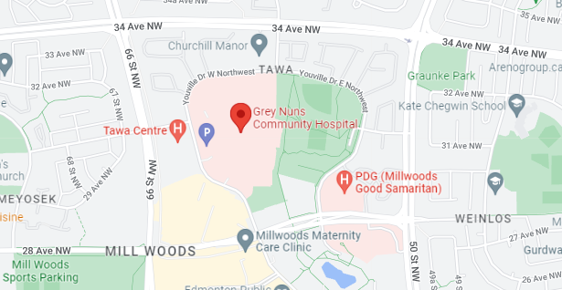
On-site Charge Person(s)  - Clear the risk of further harm to the injured person by securing the area and shelter the injured person from the elements  - Designate who is in charge of the other participants  - Protect yourself (wears gloves if he/she is in contact with body fluids such as blood)  - Assess ABCs (checks that airway is clear, breathing is present, a pulse is present, and there is no major bleeding)  - Wait by the injured person until EMS arrives and the injured person is transported  - Fill in an accident report form |  | Option 1:  Option 2:  Option 3:
On-site Call Person(s)  - Call for emergency help  - Provide all necessary information to dispatch (e.g. facility location, nature of injury, what, if any, first aid has been done)  - Clear any traffic from the entrance/access road before ambulance arrives  - Wait by the driveway entrance to the facility to direct the ambulance when it arrives  - Call the emergency contact person listed on the injured person’s medical profile |  | Option 1:  Option 2:  Option 3:

