Team Official Checklist - Indoor Season
- Visit www.emsasoccerportal.com and complete the “Register a Team Official” form for yourself.
- Complete an up-to-date Police Information Check
  - Will be required to complete one if this is your first-time coaching OR if yours is expired
The EMSA South office with contact you regarding how to complete the Police Information Check online
- Submit info for a EMSA Coach Card
  - Required for all team officials (U9+) before the first game
The MWSA will contact you if you require a card (new team officials and those with expiring cards)
- The EMSA South will assign you to a team in TeamSnap closer to the season start date
- Contact players and parents via TeamSnap to introduce yourself once teams are released.
- If your team does not have a team manager, message all parents to try and fill the position.
- Attend EMSA South Coach Meeting to learn about coach training and expectations.
- Complete required NCCP Coach Training for the age group you are coaching – a chart with required training is available at the end of the checklist.
  - Officials must complete the training once confirmed they are on a team and prior to the season start date. Once completed, submit completion certificate and receipt for course and the zone will reimburse you
- Review Coach Manuals on the Coaches Corner https://emsasouth.com/coachref/coachs-corner/
- Community Soccer Directors will be in contact to coordinate a time for equipment pick up.
- U9+ teams must enter Jersey #’s for their players in the EMSA soccer portal prior to the first game.
- Practice and Game Schedules will be made available 48 hours prior to the season beginning.
- Enter all practices + games into TeamSnap for the team to view.
- Run practices based on resources from the Technical Director.
- For teams U9+, home teams will need to provide a printed copy of the game sheet.
- Submit game sheet to the following offices by the morning after the game:
  - U9-U19 – Submit to EMSA Main office (see season info https://emsamain.com/seasoninfo/outdoorseason/)
  - All U11+ home teams submit scores in the EMSA Soccer Portal by the morning following the game.
- 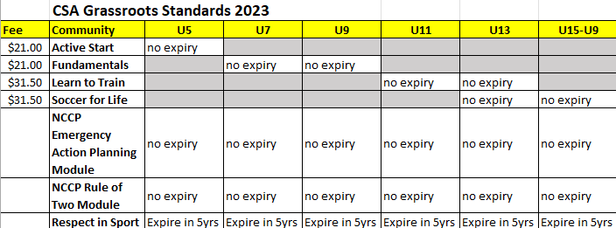
Managers only require Respect in Sport

